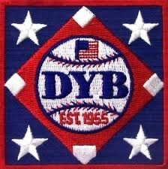

**LETTER OF INTENT FOR HOSTING 2024 DYB STATE TOURNAMENTS**

Leagues that would like to be considered as host for the 2024 State Tournaments must complete this form and return to the State Director by **Friday, January 27, 2023.**

LEAGUE NAME: _____________________________________________

LEAGUE CONTACT: __________________________________________

FIELD DIMENSIONS: __________________________________________

PREVIOUS TOURNAMENTS HOSTED: ___________________________

**(2024 STATE TOURNAMENTS PLEASE CHECK ALL THAT APPLY)**

O-ZONE: DIVISION 1_______ DIVISION 2________

AAA: DIVISION 1_______ DIVISION 2_________

AA: DIVISION 1_______ DIVISION 2_________

(ROOKIE LEAGUE) DIVISION 1_______ DIVISION 2_________

PLEASE RETURN LETTER OF INTENT VIA EMAIL:

**scdyb@dybusa.org**

**\*\*\*DEADLINE IS FRIDAY, JANUARY 27** **